Build Your Second Brain With Claude Code & Obsidian
How to use them in tandem to organize and maintain a personal knowledge base.
Feb 26, 2026

Bonus: Grab the Claude Code Playbook and a swipe file with 100+ use cases.
Look, I wasn’t gonna get all fanboy about this.
I really wasn’t.
When I first wrote about Claude Code last month, I figured it’d be a one-off exploration.
But then something happened that—if I’m honest¹—rarely happens with most AI tools I try: I started regularly using Claude Code in my daily life.
Like, a lot.
So much so that it’s now my primary driver rather than the usual ChatGPT Plus.

Oh, the sweet irony of forcing ChatGPT to create this image.
Because of this, I started wondering whether my current folder setup and the way I feed context to Claude Code are as good as they can be.
That’s how I eventually landed on concepts like “Personal knowledge base” (PKB) and apps like Obsidian.
Then I asked Claude Code to help me set everything up, and I now have a future-proof foundation for capturing knowledge and managing context.
Let me show you how you can do the same.
If you followed along, you should already know how to:
- ✅ Get Claude Code up and running on your computer
- ✅ Set up and use an IDE, Skills, and MCPs with Claude Code
- ✅ Identify what Claude Code can help you with (and know how to ask for it)
Today, let’s look at how Claude Code can help you organize and maintain your context going forward.

Wait…doesn’t Claude Code already manage its own context?
It does.
I even said as much in my last article:
“But here’s one of my favorite things about Claude Code: Your entire working folder is the context. You don’t have to curate and upload individual files to separate conversations. Every new Claude Code chat has access to this full context by default.”
Out of the box, Claude Code already reads your files, saves stuff in MEMORY.md, and can create and edit multiple CLAUDE.md files to give itself additional context.
But there are a few things I’ve come to believe after digging into Claude Code tutorials and watching half the AI Internet² lose its damn mind over OpenClaw:
- Always-on, personal AI agents are coming: OpenClaw was a vibe-coded one-man project, with all the risks and rough edges that entailed. But it showed the industry that people are hungry for capable agents that take action proactively and can chat with you from just about anywhere. OpenAI already snatched Peter Steinberger (OpenClaw’s creator), so you best believe we’ll soon see official, polished versions of such agents.
- “Your brain isn’t a filing cabinet”: In one of his many posts about Claude Code, Michael Crist said something I agree with: Our brains are built for having ideas and executing on them. Everything in between is busy admin work: color-coding your Trello boards, optimizing your tags, checking off to-do lists, shuffling tasks between “In progress” and “Done,” and so on. That’s why the concept of a self-maintaining personal knowledge base is increasingly fascinating to me.
Given this, I think it makes perfect sense to start building a standalone, organized context repository, untethered from any specific agent.
That way, whenever a new awesome agent comes along—OpenClaw 2.0, Claude Code Extra, Gemini Remote, whatever—I’ll have something I can point at and say, “Here, look, this is me and everything I’m working with. Let’s go!”

It’s not you, ChatGPT. It’s me.
And that’s exactly where dedicated note-taking and personal knowledge management (PKM) apps can come in handy.
They supplement Claude Code’s “blind spots” quite nicely, because they are:
- Agent-agnostic: Your knowledge is not locked into a specific AI tool and can be organized in a way that’s easy for any future agent to parse and work with.
- Interconnected: Instead of fragmented subfolders and files, PKM apps create deep connections between different “objects” (people, places, etc.) spanning across multiple notes. Over time, this web of knowledge grows and becomes more meaningful.
- Visual: Unlike Claude Code’s chat interface, you can surface PKM connections in a visual dashboard, giving you an at-a-glance view of how everything relates. Sort of like a map of your mind. A mind map, if you will. I should trademark that term.
- Accessible on the go: PKM tools typically have dedicated mobile apps that also let you jot down quick thoughts wherever you are and sync directly to your database.
And that, kids, is why I decided to plunge myself straight off a cliff and into the PKM rabbithole. (That sentence sounded way better in my head.)

But why Obsidian, specifically?
I’ll be upfront: This isn’t the first time I’ve come across Obsidian.
Many people who work with code and knowledge organization swear by it.
So a while back, after hearing yet another recommendation, I gave it a try.
Here’s archive footage of how that went:
Don’t get me wrong.
Obsidian looked light, powerful, and flexible. I could see that, given time, you could build out a super comprehensive database of everything you ever needed.
It’s just that the process of creating all those notes and interconnections was exactly the kind of extra admin work I wanted to avoid.
But that’s exactly the point of this post: Obsidian isn’t for me.
It’s for Claude Code.
And as a tool for Claude to use, Obsidian is near-perfect:
First, Obsidian notes live in a local folder (or “vault”) on your computer. Place that folder inside your working folder, and Claude gets instant access to everything.
Second, Obsidian notes are Markdown files (.md). And guess what? That’s exactly what LLMs like Claude already prefer and use. Claude Code knows how to create, edit, and structure these.
Finally, Obsidian uses [[Wikipedia]]-style links to connect concepts across your notes, which are also trivial for Claude Code to work with.
It certainly doesn’t hurt that Obsidian is free, either.
That’s why I settled on Obsidian, but you might want to check out these alternatives:
- Capacities (cloud-based competitor with a somewhat sexier UI)
- Logseq (closest to Obsidian, works with local files, free and open-source)
- Notion (requires quite a bit more legwork to hook up to Claude Code)

Here’s how to set it up
Honestly?
You can be up and running in just three steps if you want:
Step 1: Grab and install the Obsidian app (it’s 100% free):


Or get it for Mac, if you’re a monster.
Step 2: Create your Obsidian vault as a subfolder under your Claude Code folder:

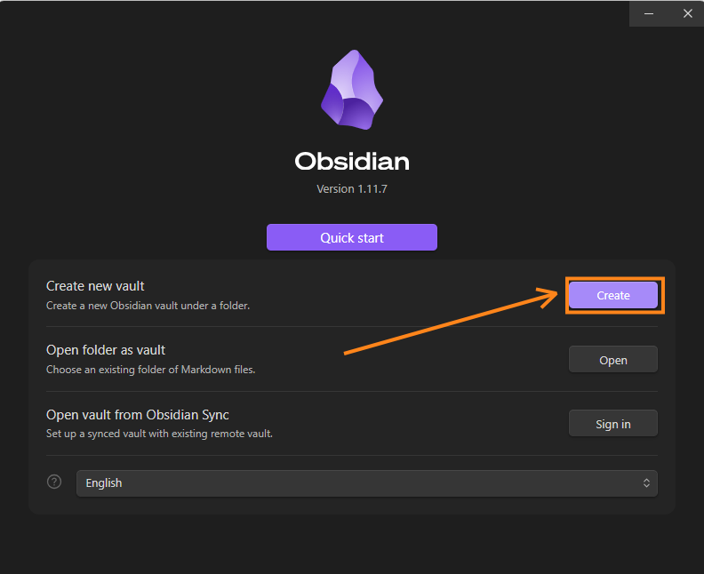

Mine looks like this, because of course it does:

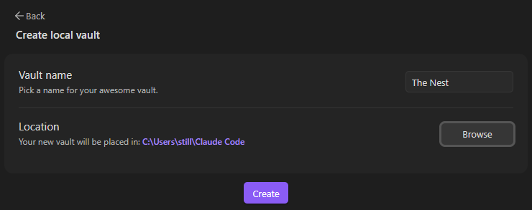

Step 3: Ask Claude Code to set things up for you.
Once the vault is there, Claude Code can populate it with notes and structure everything for you, even if you’re starting from scratch.
Here’s a kick-off prompt you can use:
Prompt: I want to use Obsidian to help you and me better manage our context. The Obsidian Vault is here [FOLDER LINK]. Ask me about my goals, tasks, preferences, etc. to get this right. Ask one question at a time. If my answers lead to more questions, ask those one at a time as well. Continue until we are fully aligned. Look up best practices and guides for Obsidian + Claude Code that fit our specific needs. Once everything is clear, propose a new folder structure and starter files for me to approve. Then execute, creating new files and moving existing ones as needed.
I did something similar. Claude Code interviewed me, made a plan, and then built the entire first version:

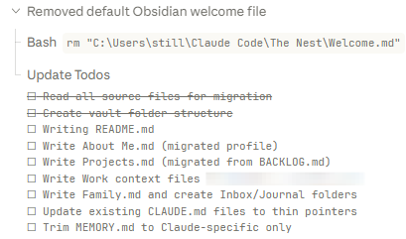

It can do the same for you, so you get a basic structure to work from.
Then, if you want to take things further…

Optional extras
My approach lets Claude Code tailor Obsidian to you and your life instead of trying to fit everything into an off-the-shelf framework.
But hey, maybe you love ready-made frameworks. I don’t know your life.
So here are a few optional steps:
Step 4 (optional). Pick your framework
There’s no shortage of ways to organize your Obsidian vaults.
(Hint: You can even ask Claude Code to research them for you.)
Michael Crist has a template for capturing and organizing your meeting notes.
Yes, And Also No has one for your entire life.
Perhaps the most well-known framework of them all is Tiago Forte’s PARA method:

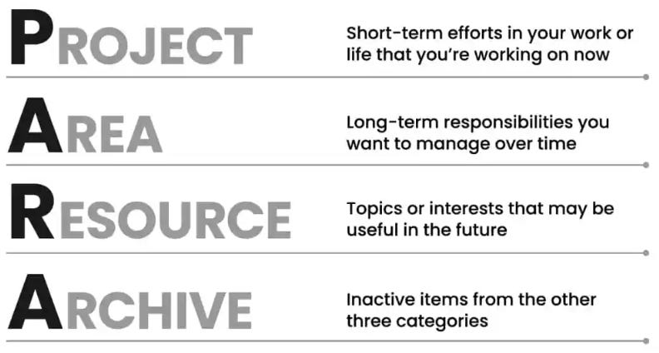
Source: Fortelabs.com
If that’s your jam, you can even find prebuilt PARA Starter Kits for Obsidian.
The point is: Pick your preferred approach and have Claude Code structure it.
The good news is that you’re never married to your setup.
Once your initial notes are ready, you Claude Code can shuffle them around, reorganize your project folders, or adopt new working frameworks…all without losing existing context.
Step 5 (optional). Set up your on-the-go capture flow³
If you’re the kind of person who takes notes throughout the day, lugging a laptop around in your pocket to run Claude Code isn’t practical.⁴
But quickly jotting things down on your phone is.
Luckily, you can sync your phone with most PKM tools (many are even cloud-based by default).
In the case of Obsidian, you have several options.
First, Obsidian has an official Sync feature ($4 per month).
Or, if you’re a cheapskate like me, you can use a free app called Syncthing.
And yes, Claude Code is the one who proposed it, along with the idea of sharing it with my readers:

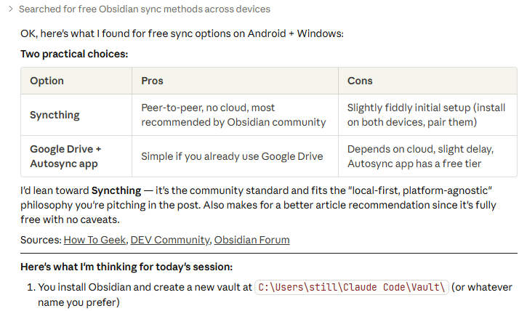

Syncthing is free and Claude Code can walk you through the entire process (it’s pretty straightforward). In my case, I now have a dedicated “Inbox” folder with a file called “Brain Dump.md” where I can throw any thought and notes while away from home:

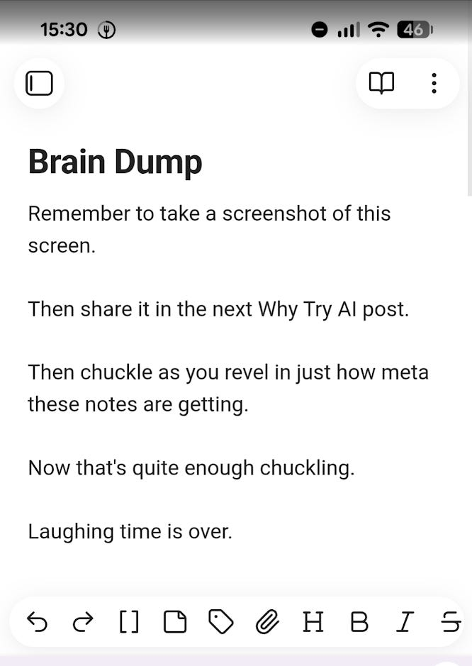

The next time I open Claude Code, it can just check the inbox, talk to me about my notes, then move them into relevant folders, update relevant files, and so on.
Nothing gets lost and everything gets properly filed.

Here’s how to keep things fresh
You now have a working setup, but your vault can quickly get outdated if you let new info fall through the cracks.
Luckily, there are a few things you can do to keep your knowledge base up to date.

1. Auto-trigger an “Inbox” check at session start
Claude Code operates with so-called “hooks,” which are trigger points that can make Claude take predetermined actions.
One of these is “SessionStart“ and you’ll never guess when it fires!
Just ask Claude Code to set this up:
Prompt: Set up a SessionStart hook that checks my vault’s Inbox folder at the start of every session. If there are new notes or content waiting, surface it in your context so we can discuss it together before starting other work.
That’s basically what I did.
Now, whenever I start any new Claude Code chat, it automatically scans for those on-the-go notes (See “Step #5” above.). I don’t have to explicitly ask for this:

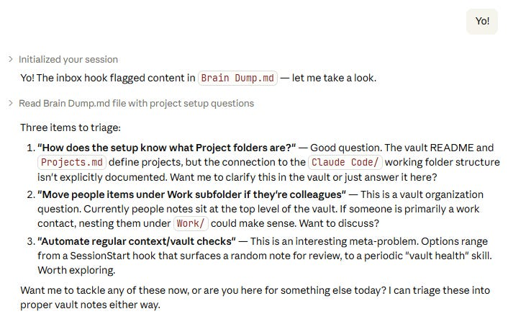

Neat!

2. Create a “vault review” skill
Claude Code can create its own skills, and you can simply ask it to make one that reviews the state of the vault, looks at your current conversation, and suggests any necessary updates.
You can try something like this:
Prompt: Create a skill called /vault-review. When I run it, it should read through my Obsidian vault notes, compare them against what we discussed in the current session, and propose any updates: new context to add, outdated info to fix, missing connections between notes. Show me the proposed changes before making them.
Now, whenever you use the /vault-review⁵ command, Claude Code will do this vault sanity check for you.
In my case, I already had a broader /session-review skill, so Claude Code folded the vault check into it as “Phase 3”:

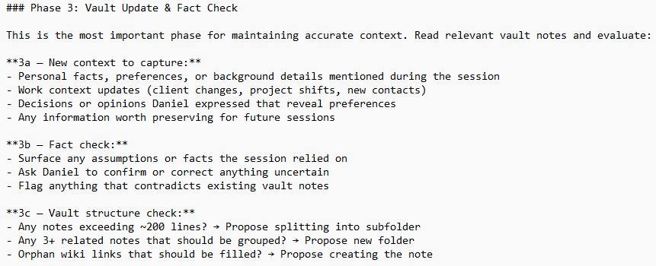
Claude Code wrote these instructions. I might expand or tighten them later.
The only downside to skills is that you have to remember to manually trigger them.
But there’s nothing stopping you from revisiting any past session and running the /vault-review on it whenever you want.

3. Set up an indexing system
Full disclosure: I haven’t tried this myself yet.
Since I’m just starting out, my vault is still pretty small. Only a few folders with a couple of .md files each.
But if your vault grows much larger, consider this recommendation from Michael Crist’s article:
Tell Claude Code to create an index.md file inside each of your main folders. The index is just a short description of what’s in the folder and what the key files are. You can do this right now. Open Claude Code in your vault and type:
Go through each folder in this vault and create an index.md file
for each one. Each index should describe what the folder contains
and list the key files inside it.
The index files are doing 80% of the work. They’re the map that tells Claude Code how to navigate your vault without reading every single file.
Oh yeah- and here’s one more tip. At the bottom of your CLAUDE.md file, add this line:
## Maintenance
- Every time you create or delete a file, update the index.md in that folder.
Now Claude becomes the librarian for all your information. It keeps its own map current without you ever having to think about it.
There you have it, folks!
Now go grab Obsidian, create your vault, and set up a knowledge base of your own.
Just remember to keep the setup simple to test the waters.
All those more fancy frameworks will still be there when you’re ready to upgrade.
1
Side note: I’ve been avoiding em dashes in my writing lately, ever since they became a shorthand for “Ha, ChatGPT wrote that!” But now I decided, screw that! I won’t be changing how I write just because LLMs have claimed the em dashes for themselves. Bite me, LLMs!
2
“AInternet”? “Intern-AI-t”? “Shut up, Daniel, both of those are stupid as shit!"?
3
Just as I was drafting this section, I saw that Anthropic just launched “Remote Control” that lets you leave your laptop running and continue your Claude Code session from e.g. a smartphone. So Claude Code can now simply make the updates to Obsidian for you, skipping this note-taking step entirely. But because this is meant as an agent-agnostic guide, I’ll still walk you through the basics.
4
Trust me, I checked: They don’t make laptop-sized pockets.
5
You can replace “vault-review” with whatever name you prefer.

